**Women’s Retreat**

*St. James Anglican Church*

6025 Old Church Road

Caledon East

**Saturday Nov. 2**

**10:00 am to 3:00 pm**

$20.00 registration fee, lunch included

With Christmas just around the corner, is your ‘to-do’ list growing?

As a woman of faith, *or a woman who would like more faith*, do you wish you had more time for God?

We want to share our lives with God. We want to pray effectively for ourselves, our families, our troubled world. But how do we find time for *one more thing*?

Get some inspiration through:

* uplifting music
* good food
* sharing with women who HAVE found a way to make more room for God.
* quiet time in our beautiful worship space
* break-out sessions on how, and why, to pray
* resources

Leave feeling refreshed, connected and with some positive tips and tools

to help you become the woman of faith you want to be.

*Registration is limited, please contact us before Oct. 27*

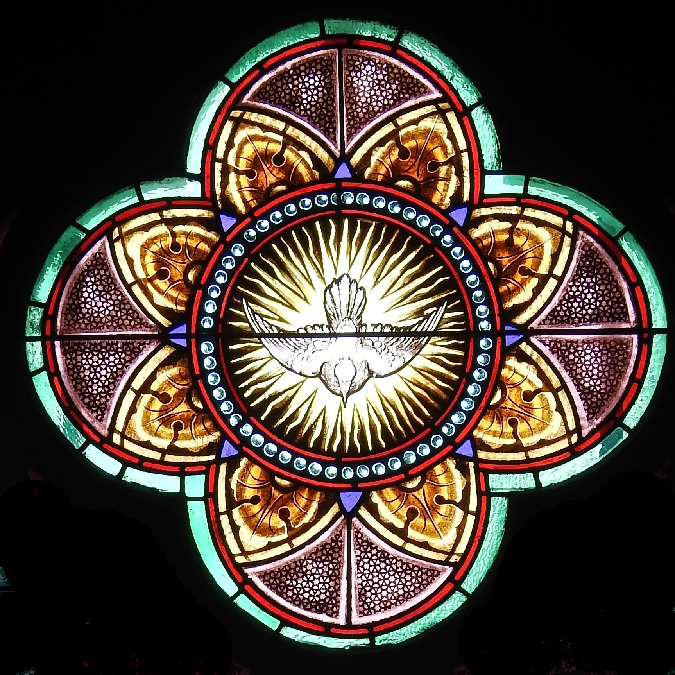

[www.stjamescaledoneast](http://www.stjamescaledoneast)

905-584-9635

[www.stjamescaledoneast](http://www.stjamescaledoneast)

905-584-9635

[www.stjamescaledoneast](http://www.stjamescaledoneast)

905-584-9635

[www.stjamescaledoneast](http://www.stjamescaledoneast)

905-584-9635

[www.stjamescaledoneast](http://www.stjamescaledoneast)

905-584-9635

[www.stjamescaledoneast](http://www.stjamescaledoneast)

905-584-9635

[www.stjamescaledoneast](http://www.stjamescaledoneast)

905-584-9635

[www.stjamescaledoneast](http://www.stjamescaledoneast)

905-584-9635

[www.stjamescaledoneast](http://www.stjamescaledoneast)

905-584-9635