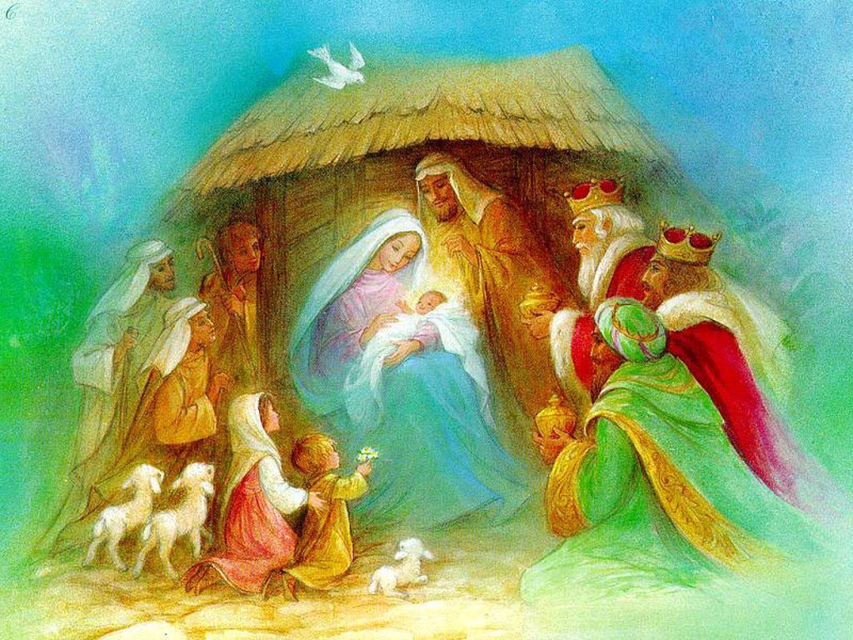

Journey to Bethlehem
…the sequel

Sunday, Dec. 8, 2019
Second Sunday in Advent

Welcome to St. James and our interactive Christmas pageant. Join us on a journey to Bethlehem led by the Little Drummer Boy. We will start in the church, then move into the Gathering Space. Feel free to sit at each stop on the way if you are more comfortable.

PROCESSIONAL HYMN #128: The Virgin Mary had a Baby Boy
The virgin Mary had a baby boy,
The virgin Mary a baby boy,
The virgin Mary had a baby boy,
And they say that his Name was Jesus.
Refrain:
He come from the glory
He come from the glorious Kingdom (2x)
O yes, believer, O yes, believer,
He come from the glory
He come from the glorious Kingdom.
The angels sang when the baby was born,
The angels sang when the baby was born,
The angels sang when the baby was born,
And proclaim him the Saviour Jesus.
The wise men went where the baby was born,
The wise men went where the baby was born,
The wise men went where the baby was born,
And they say that his Name was Jesus.

ADVENT CANDLE LIGHTING FOR THE SECOND SUNDAY IN ADVENT:
Jonathan Sorokan and his Mom, Sue Hollinger

CHOIR ANTHEM: Emmanuel is Coming!
(please sit)

SCRIPTURE: Luke 2:1-20
In those days Caesar Augustus issued a decree that a census should be taken of the entire Roman world. ² (This was the first census that took place while^{[a]}Quirinius was governor of Syria.) ³ And everyone went to their own town to register.
⁴ So Joseph also went up from the town of Nazareth in Galilee to Judea, to Bethlehem the town of David, because he belonged to the house and line of David. ⁵ He went there to register with Mary, who was pledged to be married to him and was expecting a child. ⁶ While they were there, the time came for the baby to be born, ⁷ and she gave birth to her firstborn, a son. She wrapped him in cloths and placed him in a manger, because there was no guest room available for them.
⁸ And there were shepherds living out in the fields nearby, keeping watch over their flocks at night. ⁹ An angel of the Lord appeared to them, and the glory of the Lord shone around them, and they were terrified. ¹⁰ But the angel said to them, “Do not be afraid. I bring you good news that will cause great joy for all the people.¹¹ Today in the town of David a Savior has been born to you; he is the Messiah, the Lord. ¹² This will be a sign to you: You will find a baby wrapped in cloths and lying in a manger.”
¹³ Suddenly a great company of the heavenly host appeared with the angel, praising God and saying,
¹⁴ “Glory to God in the highest heaven,
and on earth peace to those on whom his favor rests.”
¹⁵ When the angels had left them and gone into heaven, the shepherds said to one another, “Let’s go to Bethlehem and see this thing that has happened, which the Lord has told us about.”
¹⁶ So they hurried off and found Mary and Joseph, and the baby, who was lying in the manger. ¹⁷ When they had seen him, they spread the word concerning what had been told them about this child, ¹⁸ and all who heard it were amazed at what the shepherds said to them. ¹⁹ But Mary treasured up all these things and pondered them in her heart. ²⁰ The shepherds returned, glorifying and praising God for all the things they had heard and seen, which were just as they had been told.

HYMN #122: In the Bleak Midwinter
Rossetti /Holst, published 1901
In the bleak midwinter, frosty wind made moan,
earth stood hard as iron, water like a stone;
snow had fallen, snow on snow, snow on snow,
in the bleak midwinter, long ago.
Our God, heaven cannot hold him, nor earth sustain;
heaven and earth shall flee away when he comes to reign.
In the bleak midwinter a stable place sufficed
the Lord God Almighty, Jesus Christ.
Angels and archangels may have gathered there,
cherubim and seraphim thronged the air;
but his mother only, in her maiden bliss,
worshiped the beloved with a kiss.
What can I give him, poor as I am?
If I were a shepherd, I would bring a lamb;
if I were a Wise Man, I would do my part;
yet what I can I give him: give my heart.

PLAY: THE LITTLE DRUMMER BOY REMEMBERS
Written byy Diane Allengame

Old Drummer Boy (John Heighton)

It was in the bleak midwinter,
When I was but a child.

I remember a star, shining bright in the sky
The shepherds said “Go, see the new-born King.”
But I said – who am I?
Just a little Drummer Boy.

Winter gripped our land.
Snow on snow on snow.
So cold that drumming hurt my hands.
In the bleak midwinter, long, long ago

I thought I would like to see a King.
And my parents said yes --
But what gift will we bring?
We must find something on the way.

So with my drum we set out
My parents and I
Bethlehem bound, I had no doubt
I’d find a gift to give the King.

HYMN: DRUMMER BOY
Katherine Davis, 1941

Come they told me
Pa rum pum pum pum
A new born King to see
Pa rum pum pum pum
Our finest gifts we bring
Pa rum pum pum pum
To lay before the King
Pa rum pum pum pum,
rum pum pum pum,
rum pum pum pum
So to honor Him
Pa rum pum pum pum
When we come

Little baby
Pa rum pum pum pum
I am a poor boy too
Pa rum pum pum pum
I have no gift to bring
Pa rum pum pum pum
That's fit to give our King
Pa rum pum pum pum,
rum pum pum pum,
rum pum pum pum
Shall I play for you
Pa rum pum pum pum
On my drum

Mary nodded
Pa rum pum pum pum
The ox and lamb kept time
Pa rum pum pum pum
I played my drum for Him
Pa rum pum pum pum
I played my best for Him
Pa rum pum pum pum,
rum pum pum pum,
rum pum pum pum
Then He smiled at me
Pa rum pum pum pum
Me and my drum

Narrator (Diane)
So the little family packed up blankets, food and water. They headed out on the road to Bethlehem which had been taken by Mary and Joseph just a week earlier. Let’s go with them now and meet some of the people along the way.

(Please follow the Narrator into the Gathering Space)

TRAVELLING MUSIC:
Come, they told me, pa rum pum pum pum
On my drum ,rum pum pum pum

- Honest George’s Discount Donkeys and Used Camel lot (Jim Farmer)

Another family heading to Bethlehem? Boy, that sure is a popular spot. George is out getting more animals, and I’m doing his chores. Ouch, my back is killing me!

Narrator:
The little drummer boy brought a chair to Farmer Jim and helped him sit down. “That’s ok, Farmer Jim, he said. We don’t need a ride. But I need to know what to give the new- born king. if I were a shepherd, I would give a lamb. But what can I give him, poor as I am?”

Farmer Jim:
Little Drummer boy; you just helped me. Every time you help someone, no matter what you do, you are giving them a gift.

Narrator:
As he walked, the Little Drummer Boy thought about what he had heard. How was it possible to have a gift that you couldn’t see or hold? Where did that kind of gift come from? If Farmer Jim thought he had a gift, maybe the new-born king would as well. Although the sun was setting, he could just make out a large colourful tent ahead.

TRAVELLING MUSIC:
Come, they told me, pa rum pum pum pum
On my drum ,rum pum pum pum

- Stan’s Magic Mart (Stan Cameron)

Step right up folks, it’s getting late but there’s still time for magic. How is your journey going? Good. Heading to Bethleham like everyone else eh!
[Magic trick]. You look like a young man who is learning magic tricks himself. Is that so? You like to do it to make people smile? That’s wonderful. Are you going for the census? No? Oh, you are going to visit a very special new-born baby. But you don’t have a gift? Seems to me your gift is making people feel happy. That is a good gift to share.

Narrator:
The Little Drummer Boy felt a bit better. Maybe he wasn’t as poor as he thought. The family spent the night in Magician Stan’s colourful tent. The next morning, they walked along the dusty road until they came to a busy crossroad.

SONG: CHILDREN GO WHERE I SEND THEE
Trad. African-American

Leader: Children go where I send thee.
All: How shall I send thee?
Leader: I’m gonna send thee one by one
All: One for the little bitty baby,
Born, born, born in Bethlehem, Bethlehem.

(Continue with leader / All pattern)

Two for Paul and Silas
Three for the good old Wise Men
Four for the four that stood at the door
Five for the five that stayed alive.

- Chuck the Crossing Guard (Chuck Davies)
Corner of the Hebron Highway and Dead Sea Parkway

Will this day ever end? Hang on, STOP! Let these camels go through. They don’t take kindly to being stopped, and believe me, you don’t want to step where they’ve been stopped. How is your trip going? Yes, it’s a fair long journey, but it looks like you are doing well. What lies at the end of your trip? A new baby? Hmm, I’ve heard something about a special child in Bethlehem. Some say he’s even a king, if such a thing is possible. What did you say? If you were a big man you would know what to bring?”

Well, Little Drummer Boy, I think you have something special to give. You are obedient. You listened when I said stop, and that kept you safe. That is a good gift to share.

Narrator:
Now the Little Drummer Boy started to smile. That’s three gifts he had that he didn’t know he had when he left home. He practiced drumming as the family walked together. Near the turn off for Bethleham a learned lady waved to them from her roadside cave.

TRAVELLING MUSIC:
Come, they told me, pa rum pum pum pum
On my drum ,rum pum pum pum

- Elizabeth’s Scroll Cave (Elizabeth Morton)

Hello there! My what a lovely family. Do you need a little reading material for your trip? Perhaps the latest copy of Better Tents & Gardens? David’s Psalms, Readers Digest version? No money? That’s ok. I have some gently used scrolls over there, perhaps something might interest you. Oh, I see. The gift you need is for a child that can’t read yet. Can you read? Yes? Very good. Then you can share that gift with those who can’t. There are many who are infirm, blind or too young to hear good stories. You gift of sharing will bring much happiness.

Narrator:
The Little Drummer Boy was so excited he began to skip. But it’s hard to skip and keep the beat on a drum, so he went back to walking. He was sure they were almost at Bethlehem. From ahead he heard someone humming.

TRAVELLING MUSIC:
Come, they told me, pa rum pum pum pum
On my drum ,rum pum pum pum
- Sweet Adeline’s Songs for every Occasion (Irma Proctor)

Oh dear. I just can’t seem to get this song right. This could be embarrassing at the big celebration next week. I see you have a drum. Could you give me a beat to follow? That’s perfect. I wish you could stay and play with me. Where are you headed? Oh yes, there is a lot going on in Bethlehem this Hanukah. But you look sad … oh, I see, you still don’t have a gift for the baby. Why, Little Drummer Boy, you have something no one else does. You can plan the drum, and he will smile and laugh. The gift of music brings joy to everyone who hears it.

Narrator:
Finally, the Drummer Boy and his family arrived at Bethleham. The star was still shining brightly over the inn. They approached the check in desk at the Inn.

SONG: DO YOU HEAR WHAT I HEAR?
Regney/Shayne, 1962

Said the night wind to the little lamb:
Do you see what I see?
Way up in the sky, little lamb.
Do you see what I see?
A star, a star, dancing in the night, with a tail as big as a kite

Said the little lamb to the shepherd boy:
Do you hear what I hear?
Ringing through the sky, shepherd boy,
Do you hear what I hear?
A song, a song, high above the tree, with a voice as big as the sea

Said the shepherd boy to the mighty king:
Do you know what I know?
In your palace warm, mighty king
Do you know what I know?
A child, a child, shivers in the cold,
Let us bring him silver and gold.

Said the king to the people everywhere:
Listen to what I say.
Pray for peace, people everywhere.
Listen to what I say
The child, the child, sleeping in the night
He will bring us goodness and light.

- Bethlehem Inn and Conference Centre
(David) Oi vey. More travellers! This census thing has been good for business, that’s for sure. Are you in need of a room overnight? Thankfully a family just left. It’s a double mat with a wall opening facing east. I’ll need to see your personal identity papers sir. What is it, young man? A new baby born recently? Yes, I do know about it. We’ve had nothing but stinky shepherds traipsing through the place since they arrived. I’ll be glad when the mother is recovered enough to leave.

(Claire) Innkeeper, stop being so unkind. I think there is something special about that family. I have been helping with food and the other women at the inn have donated clothing. The baby is beautiful, and there is a glow to the manger that remains even when the oil has run out of the lamp. It is unusual, but somehow not frightening. They are such humble, gentle people. They are in the back, in the stable, let me take you there.

SONG: THE FRIENDLY BEASTS
Robert Davis, c. 1920

Jesus our brother, kind and good
Was humbly born in a stable rude
And the friendly beasts around him stood
Jesus our brother, kind and good.

"I, " said the donkey, shaggy and brown,
"I carried his mother up hill and down;
I carried his mother to Bethlehem town."
"I, " said the donkey, shaggy and brown.

"I, " said the cow, all white and red
"I gave him my manger for his bed;
I gave him my hay to pillow his head."
"I, " said the cow, all white and red.

"I, " said the sheep with curly horn,
"I gave him my wool for his blanket warm;
He wore my coat on Christmas morn."
"I, " said the sheep with curly horn.

"I, " said the dove from the rafters high,
"I cooed him to sleep so that he would not cry;
We cooed him to sleep, my mate and i."
"I, " said the dove from the rafters high.

Thus every beast by some good spell
In the stable dark was glad to tell
Of the gift he gave Emmanuel,
The gift he gave Emmanuel.

7. The Stable

Narrator:
The kind lady led them to the stable. The little drummer boy’s parents stayed back, so he could enter first. He saw a tiny baby wrapped up and sleeping in a wooden manger, usually used to hold food for barn animals. The baby woke up and began to squirm and whimper. The Little Drummer boy beat softly on his drum. It sounded like a gentle heartbeat, and Mary smiled as the baby settled down. Baby Jesus turned his head towards the little drummer boy for a moment, then fell asleep again.

Who are you? asked Joseph.

My name is Jonathan. I am still in school and learning to play the drum. I’m sorry we didn’t bring any gifts for your baby.

Not all gifts can be wrapped, little Drummer Boy, said Mary. You have gifts in your heart, don’t you?

Yes. I am helpful, obedient, I make people laugh, I have faith, and I can share my gift of music. And most important, I have the gift of love.

Mary said, come closer, dear boy, and look at baby Jesus. He is going to grow up to be a King among Kings, and you are the first person to make him smile. Yes, little Drummer boy, you have the best gift of all, your loving heart.

HYMN #127: O COME LITTLE CHILDREN
O come, little children, O come, one and all,
Look into the manger in Bethlehem’s stall
For there, little children on this holiest night,
Our God sends from heaven his Son, your delight.

2 He lies there before you, asleep on the hay,
With Mary and Joseph to guard him and pray,
The wondering shepherds look in at the door,
And seeing the infant, they kneel and adore.

3 Adore like the shepherds! Your glad voices raise,
With those of the angels who sing in his praise;
Your chorus will echo from earth to the sky,
With “Glory to God in his heaven most high.”

4 Receive then our hearts, which we offer to Thee,
And keep them from sin and from sin set them free;
O render them holy and blessed like Thine,
Thou Son of the Highest, Thou Infant divine.

The Old Drummer Boy: concludes

So that was how I first met Jesus. By the time he entered into his ministry and was teaching throughout Galilea, I was quite old. I listened to him and gave money where I could. One day Jesus said that the poor would be blessed in heaven, and I remembered that special meeting in a stable. The gifts I had then were gifts I was able to give to many people, all of my life. Thanks be to God for his gift of Jesus, and the real gifts of the Spirit we hold in our hearts.

CHOIR ANTHEM: ANGEL’S CAROL by John Rutter

CLOSING PRAYER: Father Chris Dow

