A Thank You for our 2019 Donation to the Ugandan Widows’ Project

Thank you so much for your congregations very generous donation towards the Widows' Garden Project. We just got word that this year’s team has successfully met with the first 29 widows in the new area, Rubingo.

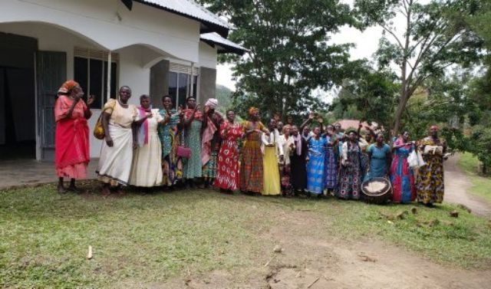

As I write they are moving to another new area.

You, or anyone else who’s interested, would be more than welcome to join the team who goes in Oct 2020!

Blessings,
Pearl Morin

